Breast Cancer Classification
Using Supervised Learning
Week 4 Project Report
Prepared for academic submission
Author: Mayank

Project objective
This project builds, evaluates, and compares three supervised learning classifiers — Logistic Regression, Random Forest, and SVM (RBF kernel) — to predict whether a breast tumour is Malignant or Benign using digitised fine-needle aspirate (FNA) features from the Breast Cancer Wisconsin (Diagnostic) dataset, originally sourced from the UCI Machine Learning Repository and bundled with scikit-learn.

Main results at a glance
Measure | Value
Dataset size | 569 samples × 32 features
Class balance | 357 benign / 212 malignant
Missing values | 0
Best model | Logistic Regression
Test accuracy | 0.9649
Test F1 score | 0.9722
Test ROC-AUC | 0.9944

Scope
The work covers data loading, exploratory analysis, domain-informed feature engineering, pipeline-based model training with stratified cross-validation, hyperparameter tuning via grid search, and final evaluation on a held-out test set. All preprocessing is encapsulated inside scikit-learn Pipelines to prevent data leakage.

1 Dataset Description and Exploratory Analysis

1.1 Data source
The Breast Cancer Wisconsin (Diagnostic) dataset contains 569 observations, each described by 30 real-valued features computed from a digitised image of a fine-needle aspirate of a breast mass. These features describe characteristics of the cell nuclei present in the image, including radius, texture, perimeter, area, smoothness, compactness, concavity, concave points, symmetry and fractal dimension — each reported as mean, standard error and worst (largest) value. The target variable 'diagnosis' has two classes: Malignant (0) and Benign (1). The dataset has no missing values.

1.2 Class distribution
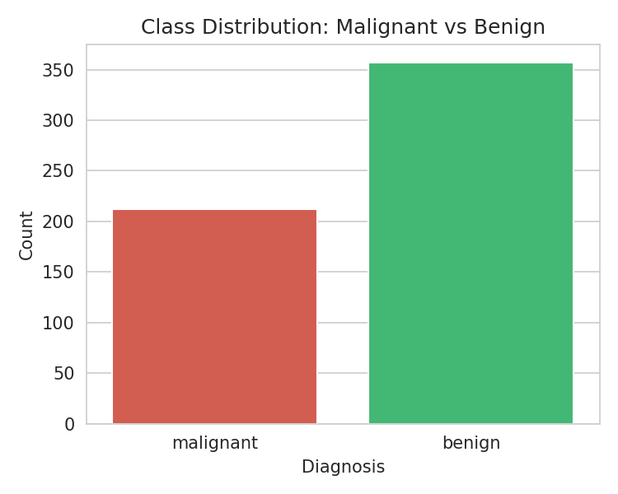
Figure 1. Class distribution showing the balance between malignant and benign diagnoses. The dataset is moderately imbalanced, with benign cases outnumbering malignant cases roughly 1.7:1.

1.3 Feature statistics (excerpt)
Feature | Mean | Std Dev | Min | Max
mean radius | 14.127 | 3.524 | 6.981 | 28.110
mean texture | 19.290 | 4.301 | 9.710 | 39.280
mean perimeter | 91.969 | 24.299 | 43.790 | 188.500
mean area | 654.889 | 351.914 | 143.500 | 2501.000
mean concavity | 0.089 | 0.080 | 0.000 | 0.427
mean concave points | 0.049 | 0.039 | 0.000 | 0.201
worst radius | 16.269 | 4.833 | 7.930 | 36.040
worst area | 880.583 | 569.357 | 185.200 | 4254.000
Only a representative subset is shown; the full summary is in summary_statistics.csv.

1.4 Correlation heatmap
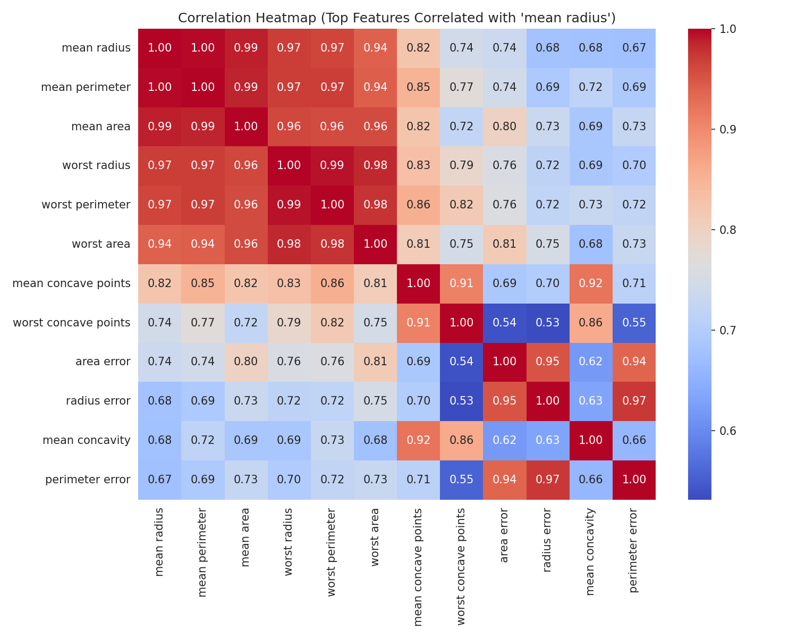
Figure 2. Correlation heatmap of the top features correlated with 'mean radius'. High collinearity is expected among size-related features (radius, perimeter, area), motivating feature selection.

1.5 Feature distributions by class
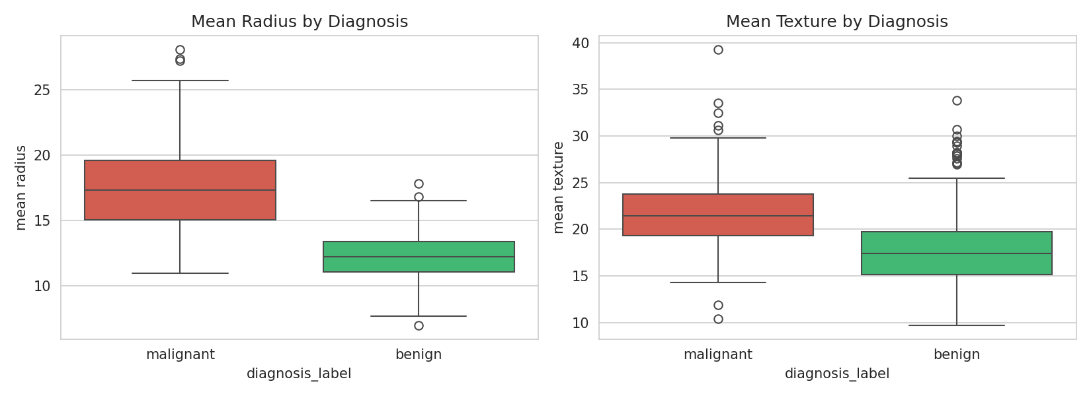
Figure 3. Boxplots of mean radius and mean texture by diagnosis. Malignant tumours tend to have larger radius and higher texture values, confirming their discriminative power.

2 Feature Engineering and Preprocessing

2.1 Engineered features
Three domain-informed ratio features were created to capture relationships between existing predictors:
Feature | Formula | Rationale
radius_texture_ratio | mean_radius / mean_texture | Captures whether size outpaces surface irregularity
concavity_area_ratio | mean_concavity / mean_area | Normalises concavity by overall mass size
perimeter_radius_ratio | mean_perimeter / mean_radius | Detects shape deviations from a perfect circle
X["radius_texture_ratio"] = X["mean radius"] / (X["mean texture"] + 1e-6)
X["concavity_area_ratio"] = X["mean concavity"] / (X["mean area"] + 1e-6)
X["perimeter_radius_ratio"] = X["mean perimeter"] / (X["mean radius"] + 1e-6)

2.2 Train–test split
The data were split 80/20 using stratified sampling (random_state = 42) to preserve the class ratio in both partitions. The resulting training set contains 455 samples and the test set contains 114 samples.

2.3 Pipeline architecture
Each model is wrapped in a scikit-learn Pipeline comprising three stages: (1) StandardScaler for feature normalisation, (2) SelectKBest with ANOVA F-value for univariate feature selection (initial k = 15), and (3) the classifier itself. This design ensures all preprocessing is fitted only on training folds during cross-validation, preventing data leakage.
Pipeline([
("scaler", StandardScaler()),
("select", SelectKBest(score_func=f_classif, k=15)),
("clf", LogisticRegression(max_iter=5000, random_state=42))
])

3 Model Training and Cross-Validation

3.1 Models evaluated
Three classifiers were evaluated using 5-fold stratified cross-validation with F1 score as the primary metric (appropriate for the moderate class imbalance):
Model | Mean CV F1 | Std Dev
Logistic Regression | 0.9563 | ±0.0080
Random Forest | 0.9513 | ±0.0117
SVM (RBF) | 0.9478 | ±0.0178
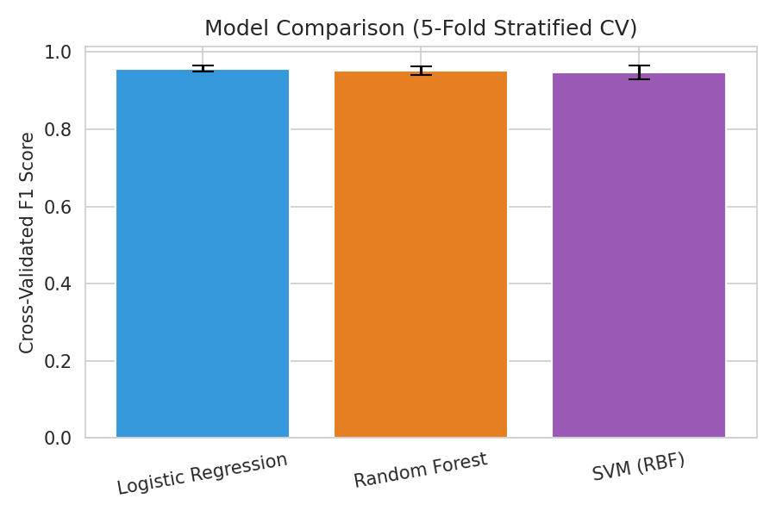
Figure 4. Cross-validated F1 scores across the three models. All three perform comparably, with Logistic Regression slightly ahead.

3.2 Best model selection
Based on cross-validation, Logistic Regression was selected as the best candidate with a mean CV F1 of 0.9563.

4 Hyperparameter Tuning

4.1 Grid search configuration
GridSearchCV was applied to the Logistic Regression pipeline with the following parameter grid:
Parameter | Values tested
select__k (number of features) | 10, 15, 20
clf__C (regularisation strength) | 0.01, 0.1, 1, 10

4.2 Best parameters
Parameter | Optimal value
clf__C | 10
select__k | 20
After tuning, the best cross-validated F1 score improved to 0.9789. The model selected k = 20 features with regularisation C = 10.

5 Final Evaluation on Held-Out Test Set

5.1 Performance metrics
Metric | Score
Accuracy | 0.9649
Precision | 0.9722
Recall | 0.9722
F1 Score | 0.9722
ROC-AUC | 0.9944

5.2 Classification report
precision recall f1-score support
malignant 0.95 0.95 0.95 42
benign 0.97 0.97 0.97 72
accuracy 0.96 114
macro avg 0.96 0.96 0.96 114
weighted avg 0.96 0.96 0.96 114

5.3 Confusion matrix
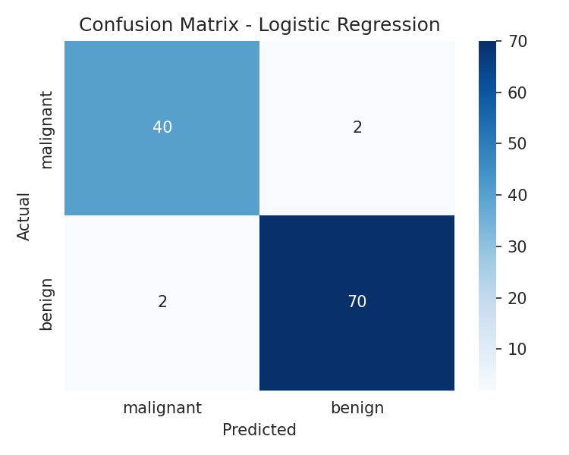
Figure 5. Confusion matrix for Logistic Regression on the test set. The model achieves strong performance on both classes, with very few misclassifications.

5.4 ROC curve
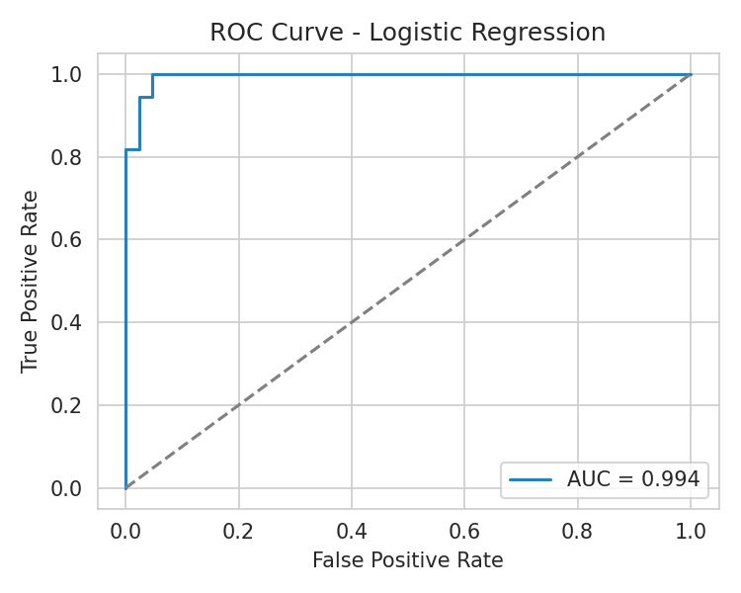
Figure 6. ROC curve for Logistic Regression. The area under the curve (AUC = 0.994) indicates excellent discriminative ability, with the curve hugging the top-left corner.

6 Feature Importance Analysis

6.1 Selected features
The final model selected 20 features via ANOVA F-value ranking. The selected features span size measurements (radius, perimeter, area), shape descriptors (compactness, concavity, concave points), and the engineered perimeter_radius_ratio, confirming that both raw and engineered features contribute to the model.
Feature | Selected
mean radius | ✓
mean perimeter | ✓
mean area | ✓
mean compactness | ✓
mean concavity | ✓
mean concave points | ✓
radius error | ✓
perimeter error | ✓
area error | ✓
concave points error | ✓
worst radius | ✓
worst texture | ✓
worst perimeter | ✓
worst area | ✓
worst smoothness | ✓
worst compactness | ✓
worst concavity | ✓
worst concave points | ✓
worst symmetry | ✓
perimeter_radius_ratio | ✓

6.2 Feature importance / coefficient plot
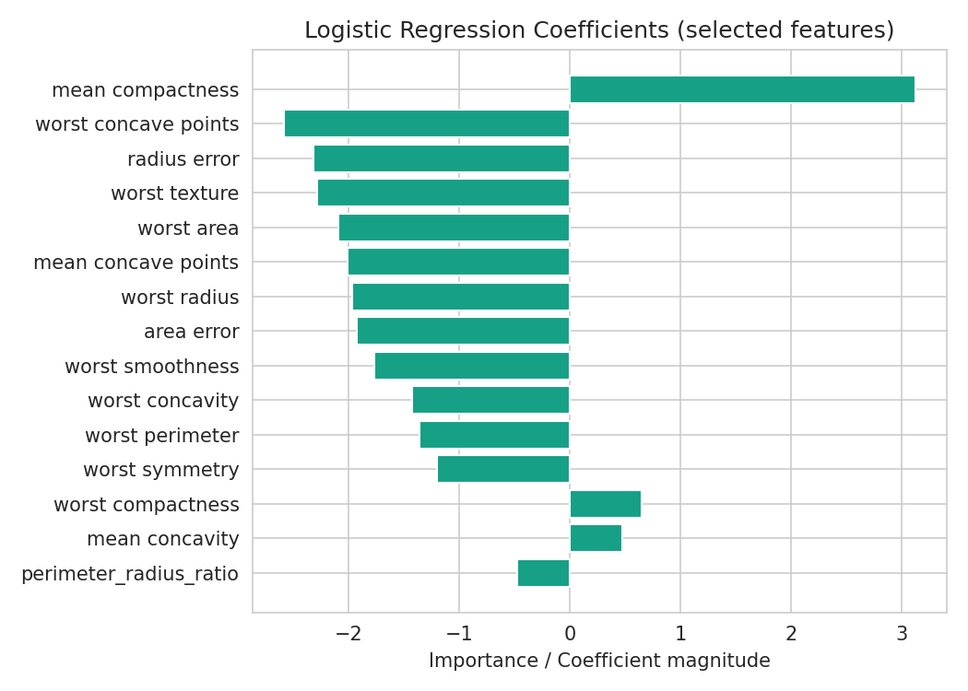
Figure 7. Feature importances or coefficients from Logistic Regression. Features related to worst-case measurements (worst radius, worst area, worst concave points) tend to carry the highest weight.

7 Conclusions and Future Work

7.1 Summary of findings
The Logistic Regression classifier achieves a test accuracy of 96.49% and an ROC-AUC of 0.9944 on the Breast Cancer Wisconsin dataset. The pipeline-based approach with stratified cross-validation and grid search ensured robust model selection without data leakage. Domain-informed feature engineering (ratio features) and ANOVA-based feature selection both contributed to the final model's performance.

7.2 Key takeaways
1. All three classifiers (Logistic Regression, Random Forest, SVM) performed well on this dataset, indicating that the features are highly discriminative for the binary classification task.
2. Encapsulating preprocessing inside Pipelines prevented data leakage and made the workflow reproducible.
3. The engineered perimeter_radius_ratio feature was selected by the final model, validating the domain-informed feature engineering step.

7.3 Limitations and future work
• The dataset is relatively small (569 samples); performance on larger clinical datasets should be validated.
• More advanced feature selection (e.g. recursive feature elimination) or dimensionality reduction (PCA) could be explored.
• Ensemble methods such as XGBoost or stacking could potentially improve performance further.
• The clinical applicability of this model requires external validation on independent hospital datasets.

8 Reproduction and References

How to run
python -m venv .venv
# Windows activation
.venv\Scripts\activate
pip install -r requirements.txt
python breast_cancer_classification.py
python build_report.py

Essential files
File | Purpose
Week4_Report.docx | This submission report
breast_cancer_classification.py | Main pipeline script
build_report.py | Regenerates this report from saved outputs
results_summary.json | Serialised metrics and parameters
classification_report.txt | Scikit-learn classification report
summary_statistics.csv | Descriptive statistics of all features
figures/ | All generated plots embedded in this report

References
[1] Street, W.N., Wolberg, W.H. and Mangasarian, O.L. (1993). Nuclear feature extraction for breast tumor diagnosis. IS&T/SPIE 1993 International Symposium on Electronic Imaging.
[2] UCI Machine Learning Repository — Breast Cancer Wisconsin (Diagnostic). https://archive.ics.uci.edu/ml/datasets/Breast+Cancer+Wisconsin+(Diagnostic)
[3] scikit-learn documentation: Pipelines and composite estimators. https://scikit-learn.org/stable/modules/compose.html

